1. The IP address of a (guvi.in) domain.

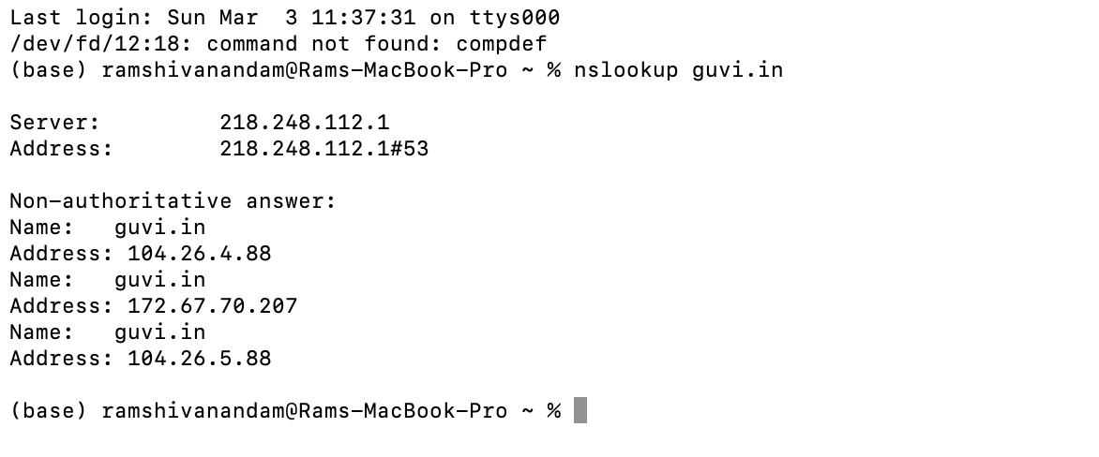

2. How do I find my server's CPU/memory usage?

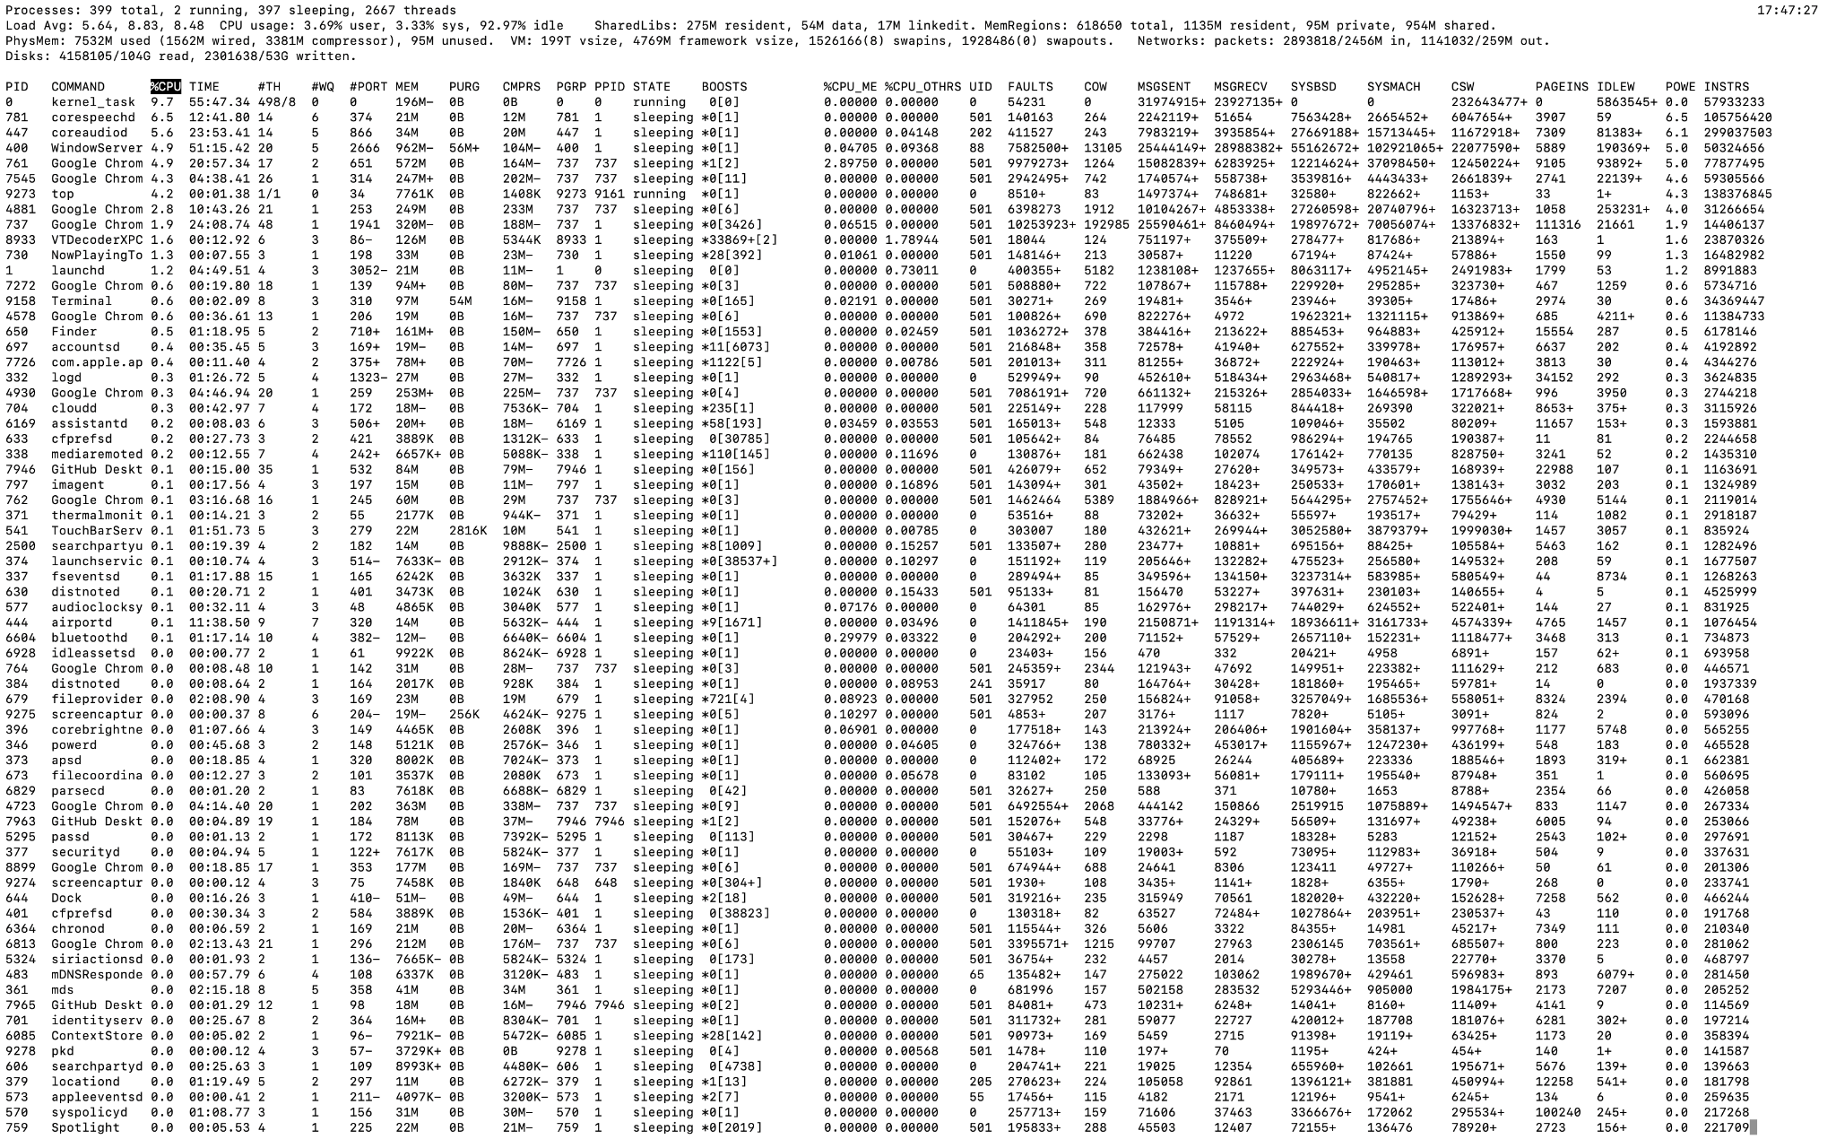

3. Test the connectivity between 2 nodes.

